Chapter-4: System Methodology

# 4.1 Introduction

In any project development process, system design is the most crucial part. In simple words, system design is the planning of how we are going to develop the actual system. For the designing system, we will go through some diagrams such as data flow diagram (DFD), schema diagram, entity relationship diagram (E-R diagram) to inspect how our proposed system will be developed and will function. From those diagrams, we learn how data will store in our system, step by step work of the user (buyer) and also business admin (seller), and how data will store in our database. The design pattern that we are focusing on is the model-view-controller (MVC pattern).

# 4.2 System Design Methodology

The **Model View Controller** (MVC) design pattern specifies that an application consists of a data model, presentation information, and control information[7]. The pattern requires that each of these is separated into different objects. MVC is more of an architectural pattern, but not for a complete application. MVC mostly relates to the UI / interaction layer of an application. You’re still going to need a business logic layer, maybe some service layer and data access layer.

# 4.2.1 System Design Components

* The **Model** contains only the pure application data, it contains no logic describing how to present the data to a user.
* The **View** presents the model’s data to the user. The view knows how to access the model’s data, but it does not know what this data means or what the user can do to manipulate it.
* The **Controller** exists between the view and the model. It listens to events triggered by the view (or another external source) and executes the appropriate reaction to these events. In most cases, the reaction is to call a method on the model. Since the view and the model are connected through a notification mechanism, the result of this action is then automatically reflected in the view.

**4.2.2 MVC Design Pattern**

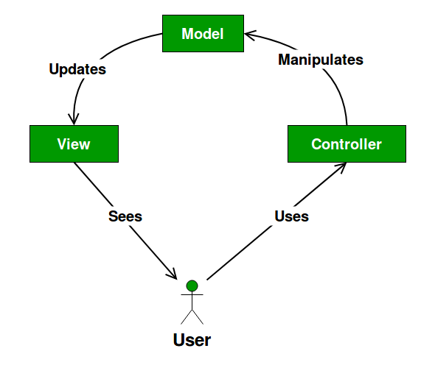

Fig 4.1 Model-View-Controller (MVC) Design Pattern

**4.3 List of Diagrams**

The list of diagrams needed for designing our proposed system is given below.

* Data Flow Diagram level-0 (DFD L-0)
* Data Flow Diagram level-1 (DFD L-1)
* User (buyer) Work Flow Diagram
* Business Admin (seller) Work Flow Diagram
* Entity-Relationship (E-R) Diagram
* Schema Diagram

**4.3.1 Data Flow Diagram level-0 (DFD L-0)**

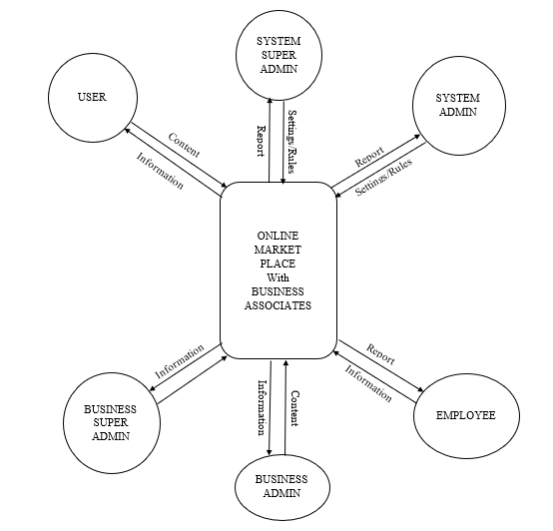

Fig: 4.2 Data Flow Diagram (Level-0) of This System

In this diagram, there is one process shown (our whole system) and input-output of data from different environments (outside). In DFD (Level 0) no database can be shown[8]. There are a total of six different environments where data can transfer. Those are:

* User
* System Super Admin
* System Admin
* Business Super Admin
* Employee
* Business Admin

**4.3.2 Data Flow Diagram level-1 (DFD L-1)**

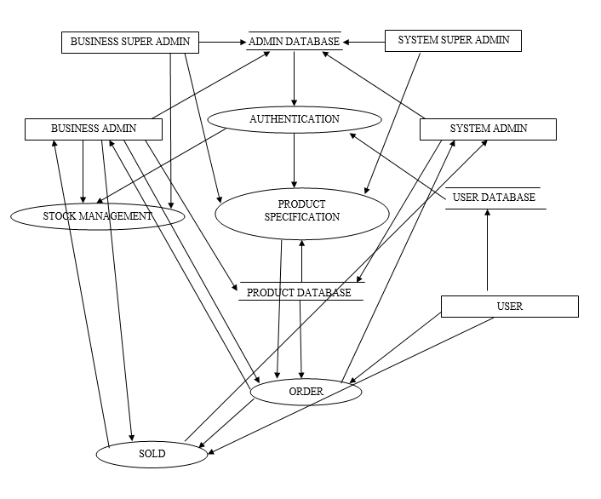

Fig: 4.3 Data Flow Diagram (Level-1) of This System

In Data Flow Diagram (Level-1) we can see some Databases, where data can store. we divided the whole system into five sub-systems[9]. They receive data from the database and environment and process data and produce output. Those sub-systems are:

* Authentication
* Product Specification
* Order
* Sold
* Stock management

There will be no miracle and black-hole in DFD (Level-1)

**4.3.3 User (Buyer) Work Flow Diagram** 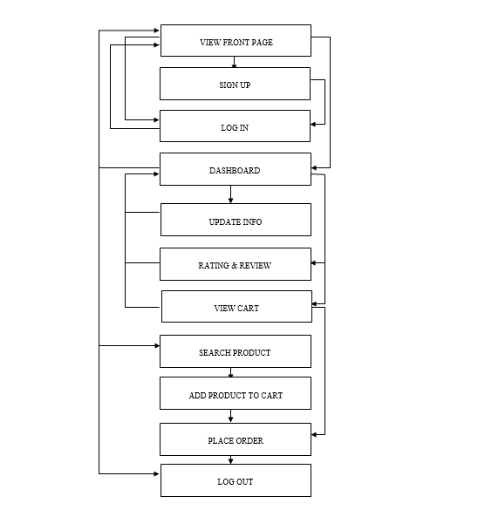

Fig:4.4 User (Buyer) Work Flow Diagram of This System

In User Work Flow Diagram, we can see how a user will use this system. After entering the system how a user can view our content, how to order product all those processes are step by step shown here. This is the procedure of how a user will interact with this system. Important work for the user is:

* Upload Information
* View Product
* Place Order

**4.3.4 Business Admin (seller) Work Flow Diagram**

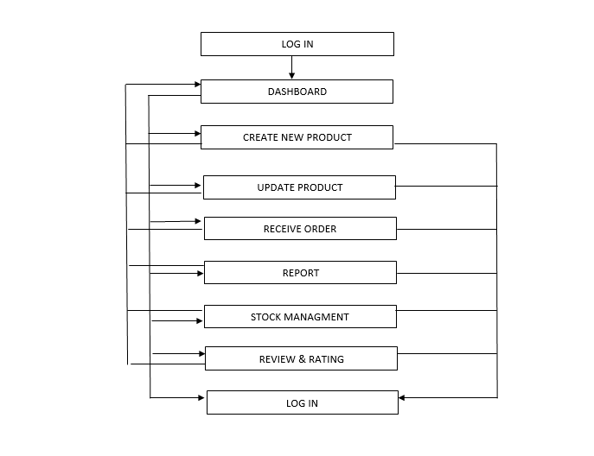

Fig:4.5 Business Admin (Seller) Work Flow Diagram of This System

In Business Admin (seller) Work Flow Diagram, we can see how Business Admin will use our system. Here we showed the full procedure of how a Business Admin interacts with this system. How he will receive an order from a user, how he can upload a new product in the system. Some important work for Business Admin is:

* View Dashboard
* Upload New Product
* Update Product
* Receive Order
* Stock Management

**4.3.5 Entity-Relationship (E-R) Diagram**

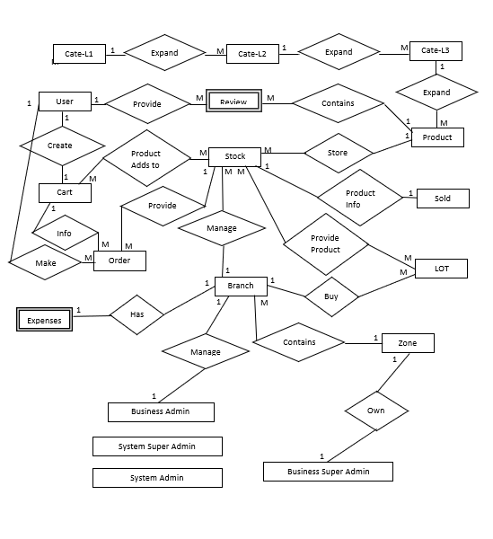

Fig :4.6 Entity-Relationship (E-R) Diagram of This System

This is an Entity-Relationship (E-R) Diagram of this system [10]. Here we show the relationship among the tables and every primary key. The type of relationship is also denoted here. In this system, there are three types of the relationship among the tables.

* One to One Relation
* One to Many Relation
* Many to Many Relation